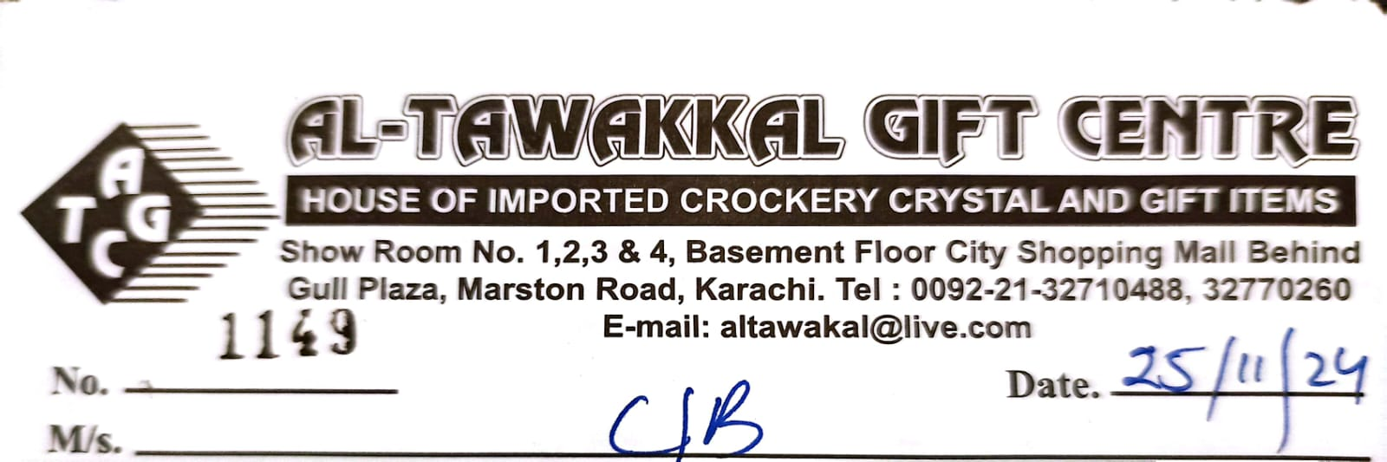
No. |  |  | Date:
M/s.
QTY | PARTICULARS |  |  | RATE |  | AMOUNT
 |  |  |  | TOTAL
NO RETURN EXCHANGE ONLY FOR WHOESALE
 | Signature:

